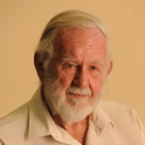 NOMINATION FORM
NOMINATED OUTSTANDING Landcare PERSON OR GROUP
Name :
What project/event/activities has this person / group been involved in and how they have made a difference?

What has your nominee contributed to Landcare?
(e.g., community involvement, nature & length of activity or service)

What do you consider makes this person or group stand out from other Landcarers?
(e.g., previous awards, nature & length of activity or service, achievements)

Nominator Name |  | Email Address
Phone Number

Nominations forms available at the Clarence Landcare Office or emailed upon request. Please contact the office on 66435009 for any further information.
Delivery date for nominations close Monday 15th October, 2018

Completed nomination forms should be :-
emailed to Clarence Landcare Chairperson Mr Henry Sheehan at nattai@hotkey.net.au

Or posted in a sealed envelope marked attention to :-
Chairperson, Henry Sheehan
Clarence Landcare, PO Box 594 Grafton 2460.

REMEMBER CLOSING DATE Monday 15TH OCTOBER, 2018
Award Panel will decide on recipient of the Jim Knight Memorial Landcare Award, this person or group will be announced at Clarence Landcare’s Annual General Meeting.
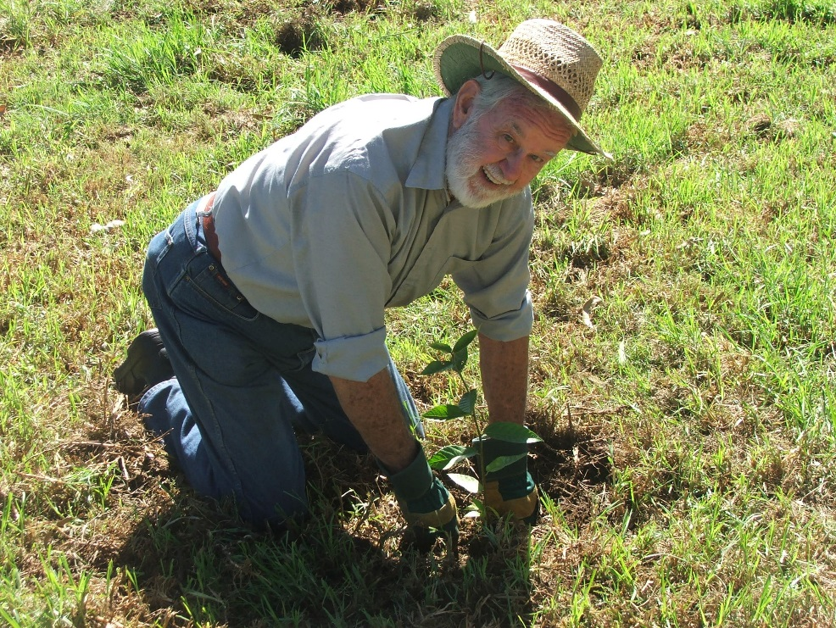

NOMINATION GUIDELINES

For “outstanding individual or group contribution to Landcare”
The aim of the Jim Knight Memorial Landcare Award is to highlight the great work and also achievements that Groups/Individuals have made within the community. Volunteering in Landcare is a rewarding experience but in many cases the achievements and work often go unrecognised within the community. This memorial award is an opportunity to showcase the wonderful work that a group or person has achieved, not only this year but in previous years and allow this work to be recognised.
Nominating Process
Nominations open 30th August, 2018 and close on 15th October, 2018. You will need to complete the official nomination form.
- Electronic copies are available on Clarence Landcare Website
- Nominations to be sent to Chair of Clarence Landcare, Mr Henry Sheehan by email to nattai@hotkey.net.au
- Hard copies are available at the front door of the office and once completed can be posted to Mr Henry Sheehan, Chair, Clarence Landcare PO Box 594 Grafton NSW 2460
Selection Criteria
- Involvement in either a successful project, activity or event
- Achievements as an individual or as part of a group or organisation
- Nature and Length of activity or service
- Community involvement
- Previous awards and recognition
Tips on writing your nomination
- Include as much supporting documentation such as personal references from others and or media promotion
- Think about how this person stands out from others and focus on achievements
- Describe personal qualities that are inspiring to others
- Ensure you write using examples of voluntary actions/work/projects

This Award has been instigated in memory of Jim Knight, peace activist, social justice champion, environmentalist and founding member of Clarence Landcare Inc.

